JIRA CASE STUDIES
100 Free Personal Case Studies with Frameworks

Beginner Case Studies (1–30)
1. Personal Productivity Management
Framework
- Goal Creation
- Task Prioritization
- Weekly Sprint Planning
- Progress Tracking
- Completion Analytics
- Retrospective

2. Student Assignment Workflow
Framework
- Subject Backlog
- Assignment Creation
- Due Date Tracking
- Progress Monitoring
- Submission Workflow
- Performance Dashboard

3. Expense Tracking System
Framework
- Expense Logging
- Categorization
- Budget Monitoring
- Approval Simulation
- Reporting Dashboard
- Monthly Review

4. Reading Management System
Framework
- Book Backlog
- Reading Sprint
- Progress Tracking
- Notes Workflow
- Completion Analytics
- Recommendations

5. Social Media Content Workflow
Framework
- Content Ideation
- Approval Workflow
- Publishing Schedule
- Performance Monitoring
- Engagement Tracking
- Reporting

6–30 Additional Beginner Case Studies
- Gym Routine Tracker
- Study Sprint Management
- Habit Tracking Dashboard
- Personal CRM Workflow
- Event Planning Tracker
- Certification Workflow
- Resume Improvement Tracker
- Online Course Dashboard
- NGO Volunteer Coordination
- Startup MVP Planning
- Budget Approval Workflow
- Time Management Board
- Marketing Campaign Tracker
- Recruitment Workflow
- Product Launch Simulation
- Training Program Tracker
- Mini Inventory System
- Help Desk Ticket Workflow
- Customer Complaint Management
- College Fest Coordination
- Freelance Client Workflow
- Goal Achievement Tracker
- Weekly Planner Dashboard
- Daily Routine Workflow
- Productivity Analytics Dashboard

Intermediate Case Studies (31–70)
31. Agile Scrum Software Simulation
Framework
- Product Backlog
- Epic Creation
- Sprint Planning
- Daily Standup Tracking
- Bug Management
- Sprint Retrospective

32. Website Bug Tracking System
Framework
- Bug Identification
- Priority Classification
- Developer Assignment
- Resolution Workflow
- QA Testing
- Closure

33. ETL Data Pipeline Workflow
Framework
- Data Source Identification
- Pipeline Task Creation
- Data Validation
- Workflow Automation
- Monitoring
- Reporting

34. Banking Loan Approval Workflow
Framework
- Loan Request Intake
- Credit Evaluation
- Risk Classification
- Approval Routing
- Compliance Validation
- Closure

35. Customer Support Ticketing
Framework
- Ticket Logging
- Severity Assignment
- SLA Tracking
- Escalation Workflow
- Resolution Monitoring
- Customer Feedback

36–70 Additional Intermediate Case Studies
- Kafka Pipeline Tracking
- Airflow DAG Workflow
- Tableau Dashboard Delivery
- Power BI Reporting Workflow
- API Testing Workflow
- Cloud Migration Tracker
- Procurement Approval System
- Inventory Monitoring Workflow
- Supply Chain Management
- Retail Operations Dashboard
- Employee Onboarding Workflow
- Logistics Delivery Tracking
- Vendor Management System
- Fraud Detection Workflow
- Insurance Claim Processing
- Financial Audit Workflow
- CRM Enhancement Workflow
- HR Performance Tracking
- Marketing Sprint Management
- SaaS Product Development
- Data Governance Workflow
- SQL Optimization Project
- MLOps Lifecycle Tracking
- AI Model Delivery Workflow
- Cybersecurity Incident Tracking
- Vulnerability Assessment Workflow
- DevOps Deployment Monitoring
- Release Management Workflow
- QA Automation Workflow
- Agile PMO Dashboard
- Change Request Workflow
- Risk Assessment Tracking
- Incident Escalation Workflow
- Product Defect Monitoring
- KPI Dashboard Development

Advanced Case Studies (71–100)
71. Enterprise Agile Transformation Simulation
Framework
- Current Process Analysis
- Agile Maturity Mapping
- Workflow Standardization
- Team Coordination
- KPI Monitoring
- Continuous Improvement

72. Cybersecurity SOC Simulation
Framework
- Threat Detection
- Incident Logging
- Risk Prioritization
- Escalation Workflow
- Resolution Tracking
- Security Reporting

73. PMO Governance Dashboard
Framework
- Portfolio Definition
- Resource Planning
- Budget Monitoring
- Dependency Tracking
- Governance Reporting
- Executive Review

74. AI Product Delivery Workflow
Framework
- Business Requirement Gathering
- Dataset Management
- Model Development Tasks
- Testing Workflow
- Deployment Approval
- Monitoring

75. Cloud Infrastructure Migration
Framework
- Infrastructure Assessment
- Migration Planning
- Sprint Execution
- Risk Management
- Deployment Monitoring
- Post-Migration Audit

76–100 Additional Advanced Case Studies
- SAFe Agile Simulation
- Enterprise Change Management
- Global Product Tracking
- Data Privacy Compliance Workflow
- Security Audit Monitoring
- Disaster Recovery Simulation
- Multi-Team Coordination
- Enterprise KPI Governance
- Strategic Portfolio Planning
- Smart Manufacturing Workflow
- AI Governance Workflow
- Blockchain Delivery Tracking
- Smart City Operations Simulation
- Telecom Incident Workflow
- Banking Compliance Tracker
- ESG Reporting Workflow
- Enterprise Risk Management
- Innovation Management Workflow
- Clinical Trial Tracking
- Aviation Compliance Workflow
- Digital Transformation Tracker
- Enterprise Release Management
- Knowledge Management Workflow
- Infrastructure Program Tracking
- Global Agile Delivery Simulation

JIRA + AI CASE STUDIES
1. AI Story Point Estimator
Objective
Use ML/NLP to predict story points from ticket descriptions.
Tech Stack
- JIRA API
- Python
- Scikit-learn
- NLP
- Flask/FastAPI
Framework
Phase 1 — Data Collection
- Extract historical JIRA tickets
- Collect:
  - Summary
  - Description
  - Story Points
  - Priority
Phase 2 — NLP Processing
- Text cleaning
- Tokenization
- TF-IDF embeddings
Phase 3 — Model Training
- Regression model
- Random Forest/XGBoost
Phase 4 — Integration
- Auto-suggest story points in JIRA
Phase 5 — Dashboard
- Prediction accuracy
- Sprint estimation reports

2. AI Bug Prediction System
Objective
Predict high-risk modules likely to generate bugs.
Framework
Input
- Past defects
- Commit frequency
- Ticket complexity
AI Layer
- Classification model
JIRA Integration
- Auto-create risk tickets
Outputs
- Bug risk dashboard
- Sprint risk heatmap

3. GPT-Based Sprint Planning Assistant
Objective
Use LLMs to automate sprint planning recommendations.
Framework
Inputs
- Team velocity
- Pending backlog
- Priority tickets
AI Engine
- GPT/LLM recommendations
Outputs
- Suggested sprint backlog
- Capacity planning
- Risk alerts

4. AI Duplicate Ticket Detection
Objective
Detect duplicate issues using NLP similarity.
Framework
NLP Pipeline
- Sentence embeddings
- Cosine similarity
Automation
- Detect duplicate during ticket creation
Outputs
- Similar issue recommendations
- Duplicate reduction analytics

5. AI Daily Standup Generator
Objective
Generate automated standup summaries.
Framework
Data Sources
- Ticket status
- Worklogs
- Comments
AI Layer
- LLM summarization
Outputs
- Daily standup report
- Team blockers
- Sprint progress summary

6. AI Sprint Health Dashboard
Objective
Predict sprint success probability.
Framework
KPIs
- Velocity
- Pending tasks
- Bugs
- Team workload
AI Model
- Predictive analytics
Outputs
- Sprint health score
- Burnout risk
- Delay prediction

7. AI Root Cause Analysis Assistant
Objective
Use AI to identify probable issue causes.
Framework
Inputs
- Incident history
- Logs
- Ticket comments
AI Layer
- NLP clustering
- Pattern analysis
Outputs
- Root cause suggestions
- Incident grouping

8. AI Resource Allocation System
Objective
Optimize task assignment using AI.
Framework
Inputs
- Team skills
- Capacity
- Workload
AI Engine
- Optimization algorithm
Outputs
- Suggested assignees
- Workload balancing

9. AI DevOps Incident Predictor
Objective
Predict deployment failures.
Framework
Inputs
- Deployment logs
- Incident history
- Build metrics
AI Layer
- Classification model
Outputs
- Risk alerts
- Failure probability

10. AI Requirement Extraction System
Objective
Convert documents into JIRA stories automatically.
Framework
Inputs
- BRD/PDF/Text
AI Layer
- NLP extraction
- User story generation
Outputs
- Auto-created backlog
- Acceptance criteria

11–25 Additional Detailed AI Case Studies
- AI QA Automation Workflow
- AI Defect Severity Prediction
- AI Agile Retrospective Generator
- AI Project Risk Management
- AI Compliance Monitoring Workflow
- AI Cloud Migration Assistant
- AI Data Governance Dashboard
- AI Security Incident Analyzer
- AI Release Readiness Predictor
- AI MLOps Governance Tracker
- AI Portfolio Prioritization System
- AI Customer Complaint Analyzer
- AI Fraud Investigation Workflow
- AI Telecom Incident Prediction
- AI Executive Project Reporting System

Best AI + JIRA Portfolio Projects for Resume
Top Resume Projects
- AI Sprint Health Dashboard
- GPT-Based Sprint Planning Assistant
- AI Story Point Estimator
- AI Duplicate Ticket Detector
- AI Bug Prediction System
- AI Root Cause Analysis Assistant
- AI DevOps Incident Predictor
- AI Resource Allocation System
- AI Requirement Extraction Tool
- AI Agile Project Manager

Suggested Architecture for AI + JIRA Projects
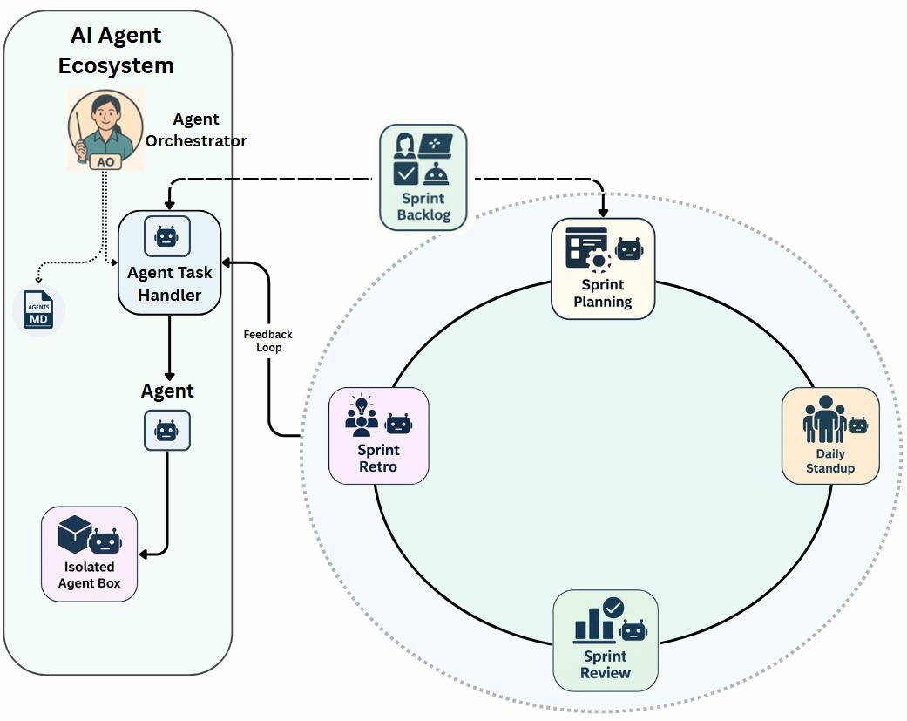
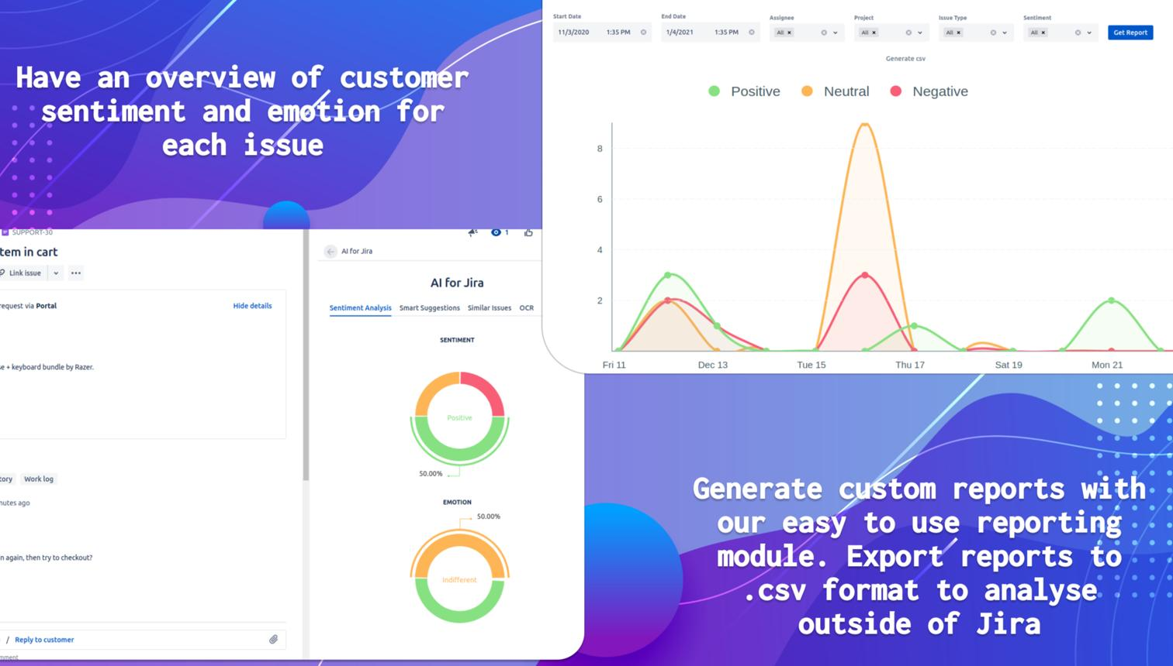
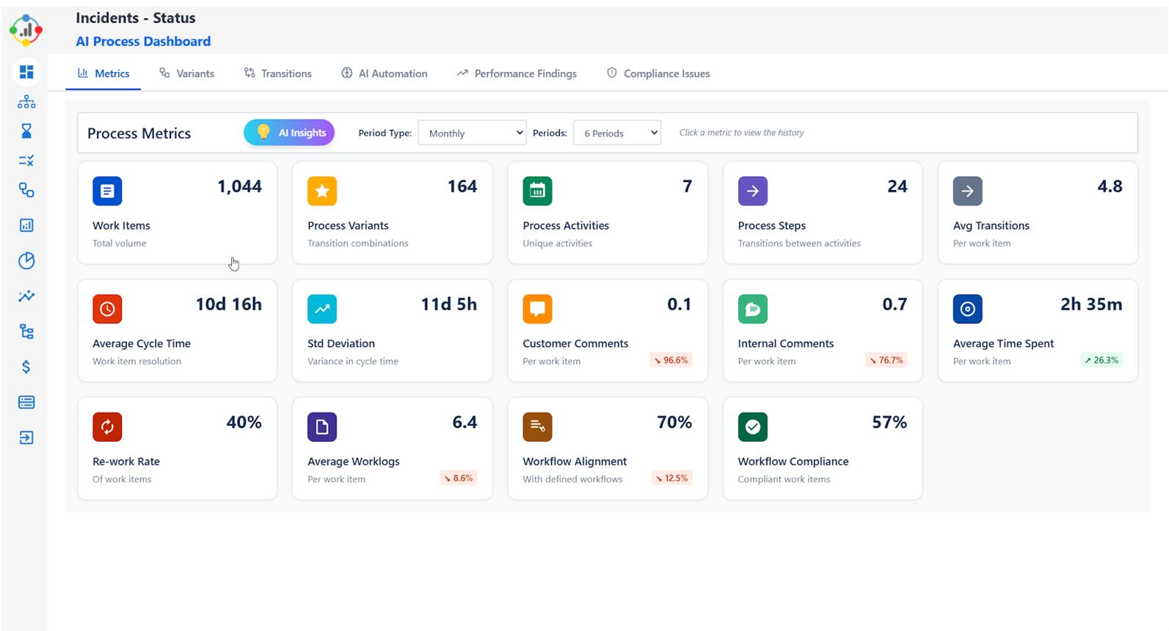
7
Architecture Flow
- JIRA API
- Python Backend
- NLP/ML Models
- Database
- Dashboard Layer
- Automation Engine
- Notification System
- AI Recommendation Engine

Free APIs & Tools You Can Use
JIRA
- JIRA Developer API
AI/LLM
- OpenAI Platform
- LangChain
- Hugging Face
Dashboards
- Power BI
- Tableau Public
Backend
- FastAPI
- Flask
ML Libraries
- Scikit-learn

